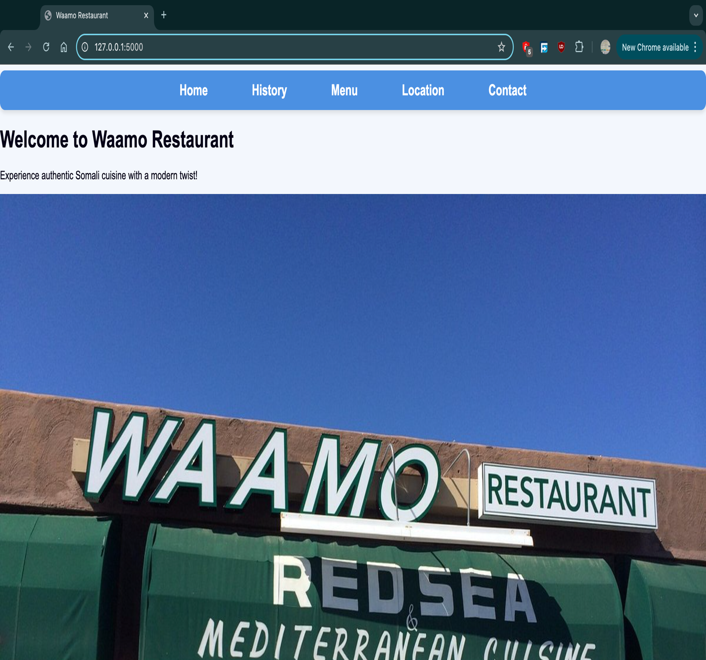

Explanation: Home Page - This is the landing page of the application. It welcomes visitors with a friendly greeting and includes a visually appealing image of the restaurant to give a sense of its ambiance. The page serves as the starting point for navigating to other sections. You might need to scroll down to see the full image and the copyright sign ‘©’ of the application in the bottom.

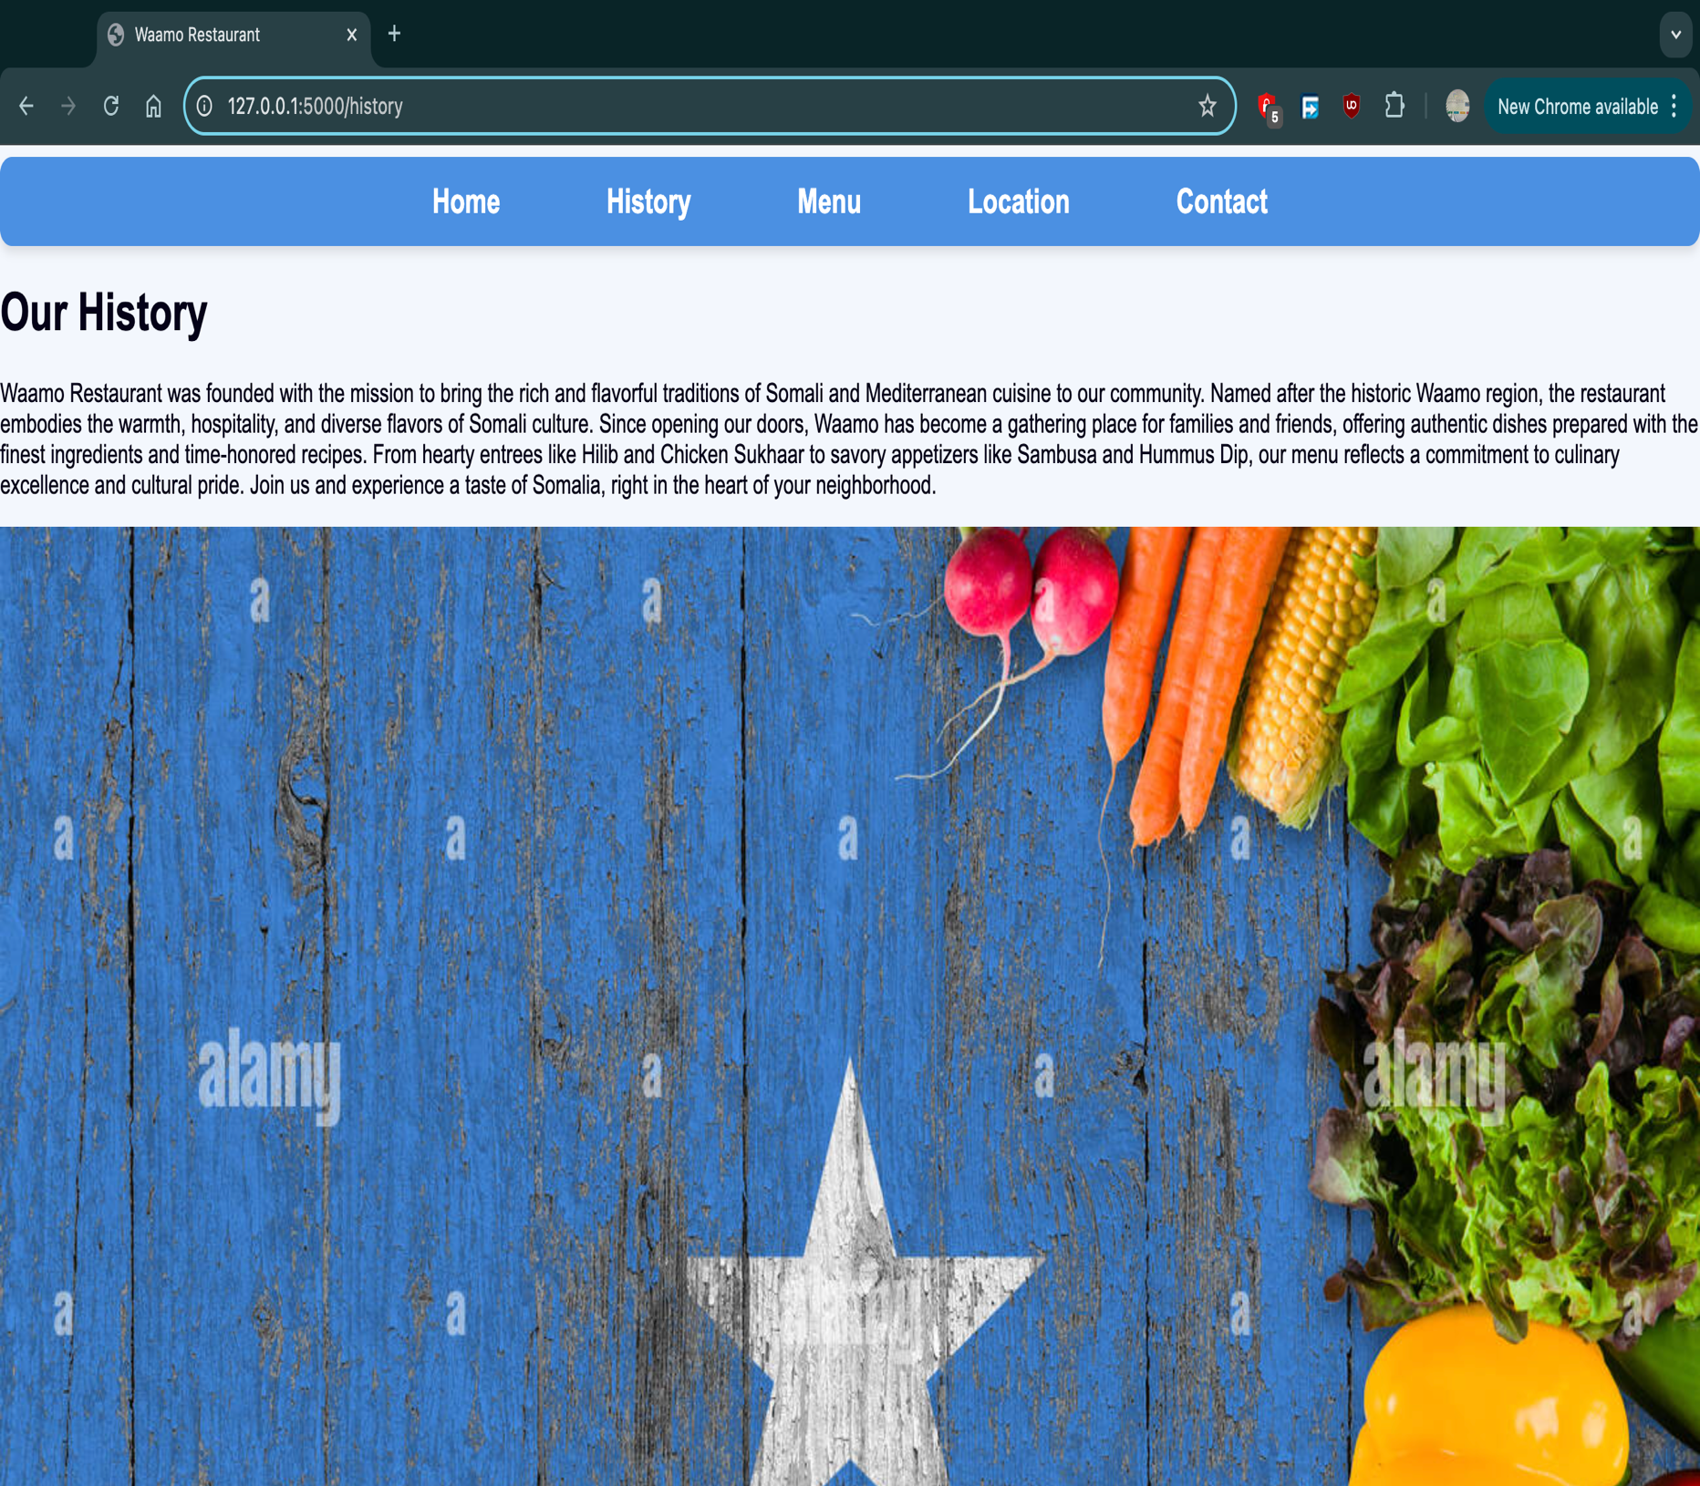

Explanation: History Page - This page provides a brief history of Somalia, highlighting how its rich cultural heritage has influenced the restaurant's cuisine. It includes a vibrant image of the Somali flag, connecting the food to its cultural roots and creating a sense of authenticity. You might need to scroll down to see the full image and the copyright sign ‘©’ of the application in the bottom.

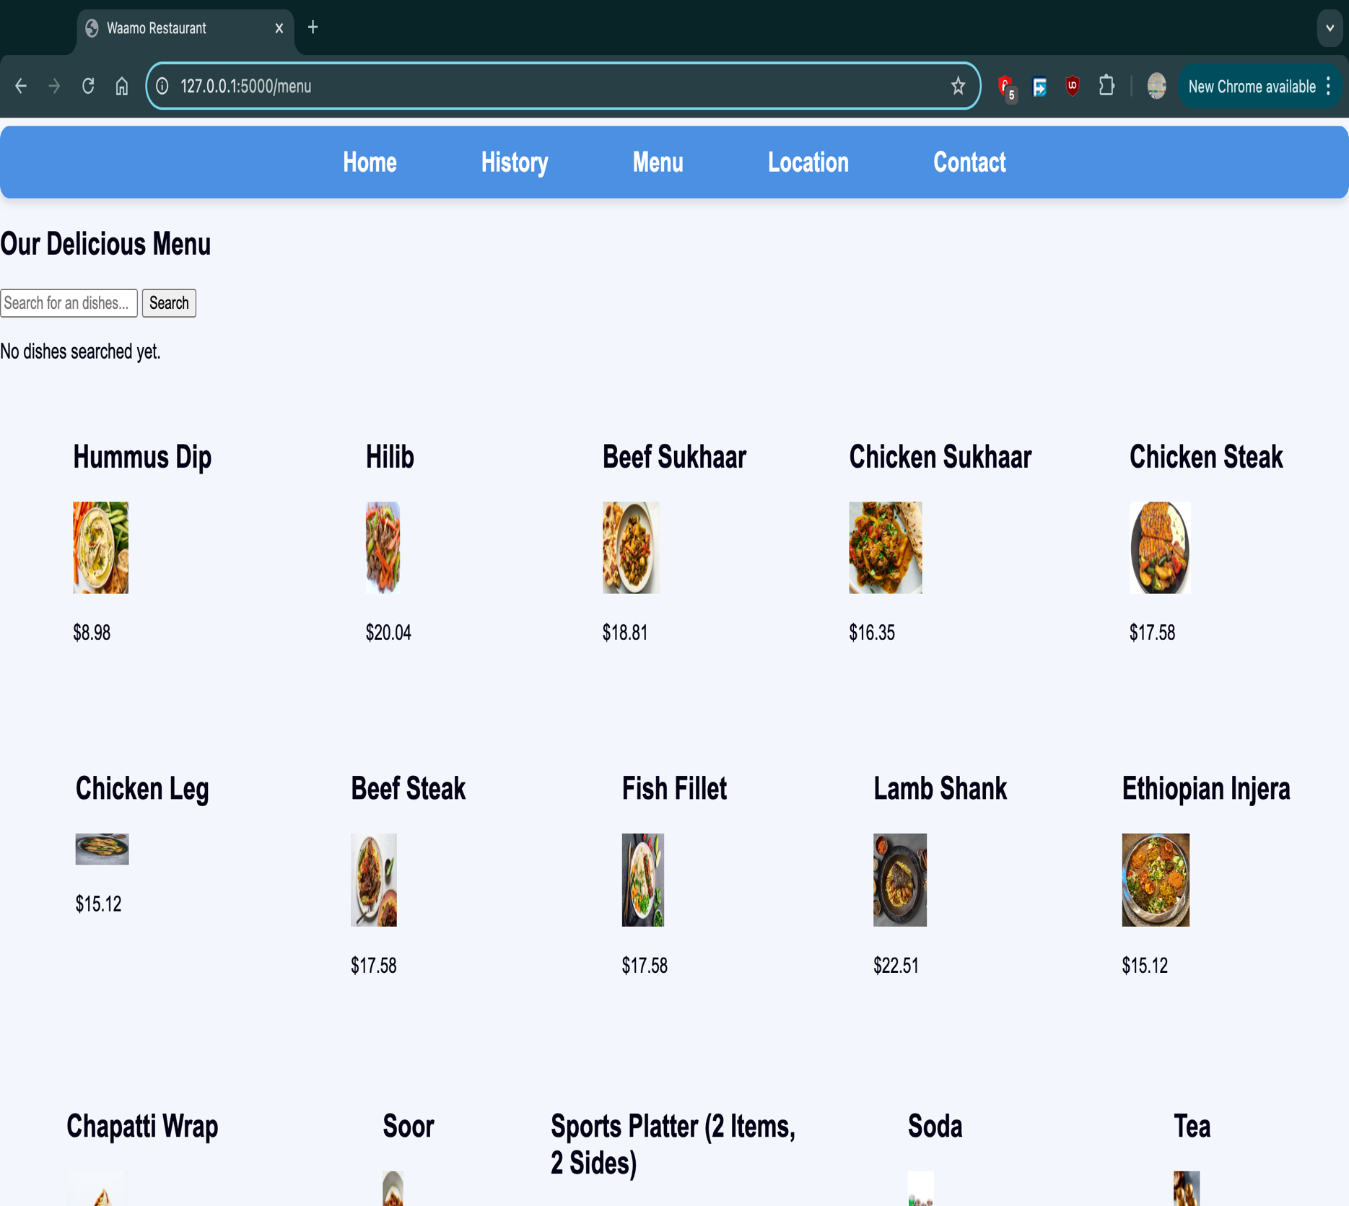

Explanation: Menu Page - This page displays the restaurant’s menu, featuring images and names of some of the dishes available. It gives visitors an idea of what to expect in terms of flavor and presentation, making it an essential stop for food enthusiasts. The search feature is implemented here. If scrolled down, there a more menu items at the bottom and the copyright sign ‘©’ of the application.

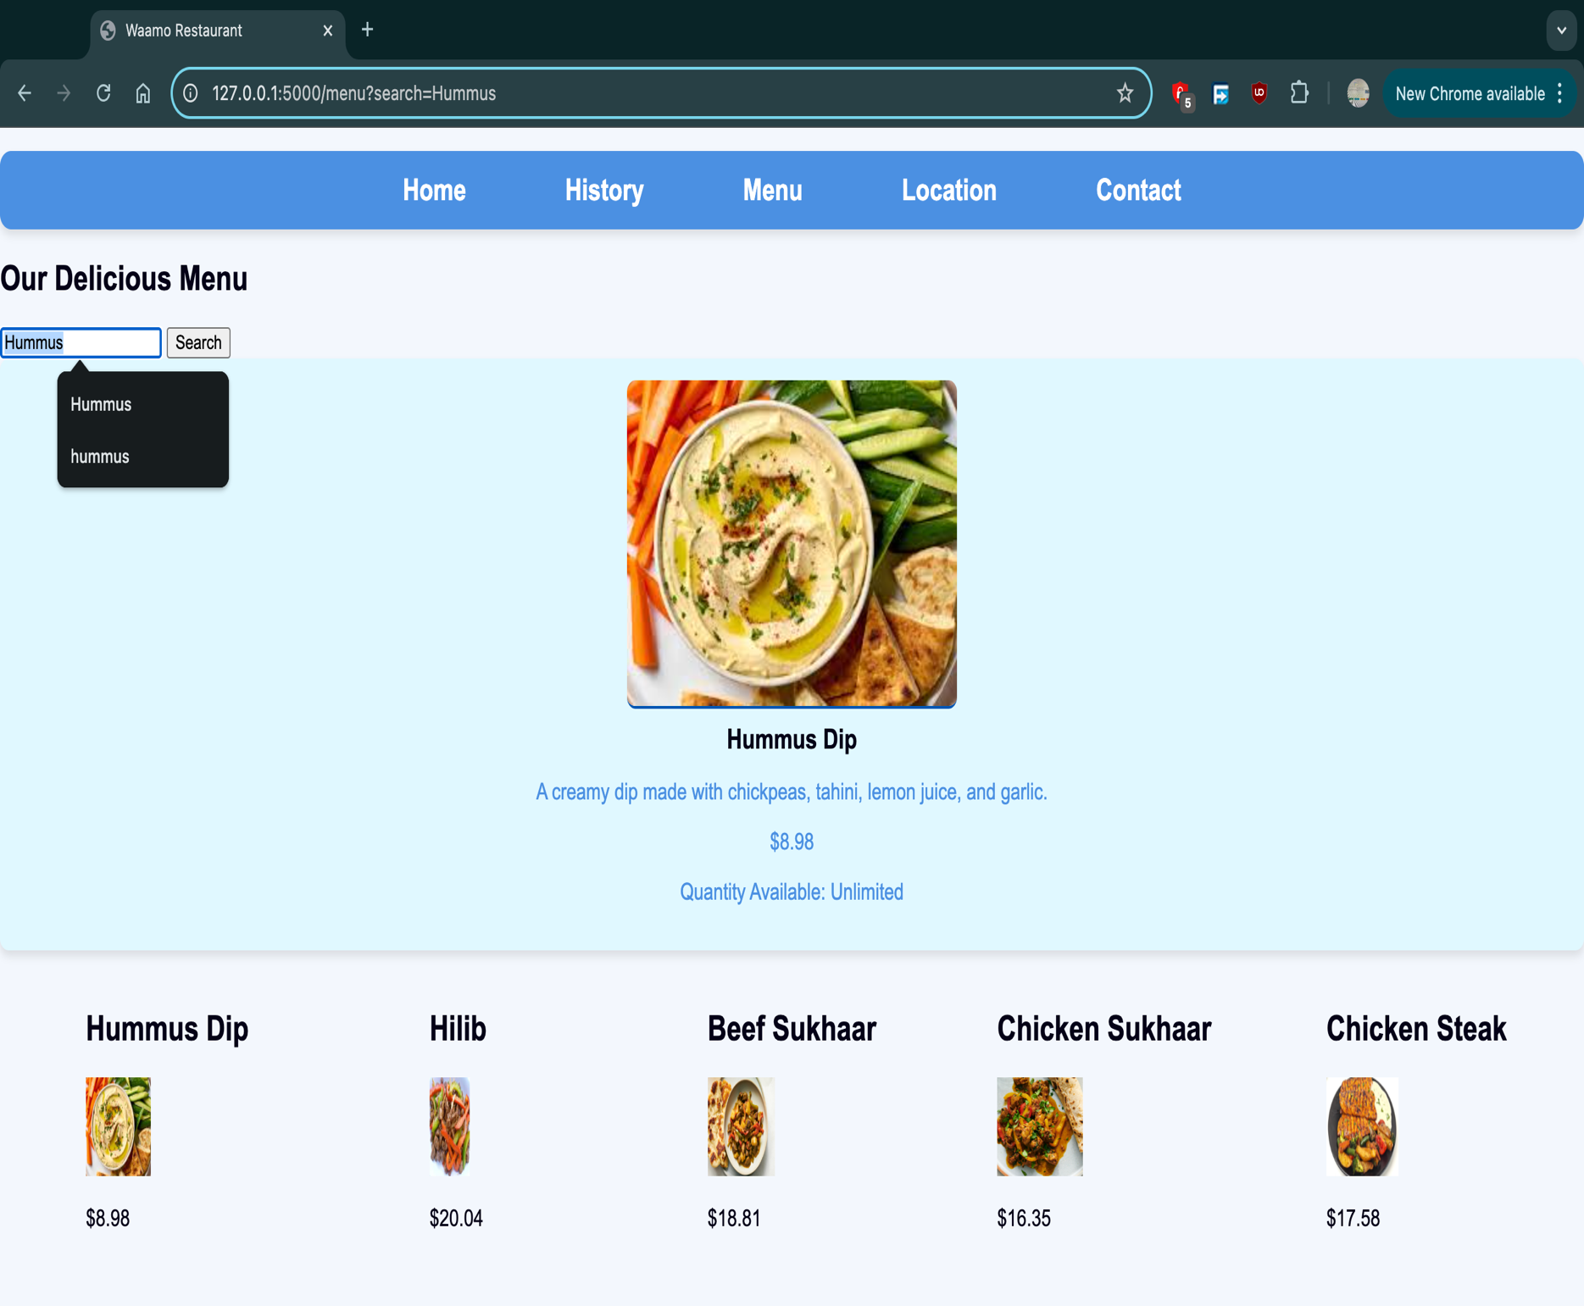

Explanation Continued: Menu Page Search feature - The search feature allows users to quickly find specific items on the menu, their description, and an image of the searched item/dish. The menu also displays the price and quantity of the dishes, but the quantity is set a default text ‘Unlimited’ since the dishes do not run out. Located on the menu page, this feature provides an input field where users can type keywords related to a dish, such as its name. The system dynamically searches the menu database and displays matching results, making it easier for users to discover their desired meals. This functionality enhances user experience by offering convenience and speed when browsing the menu.

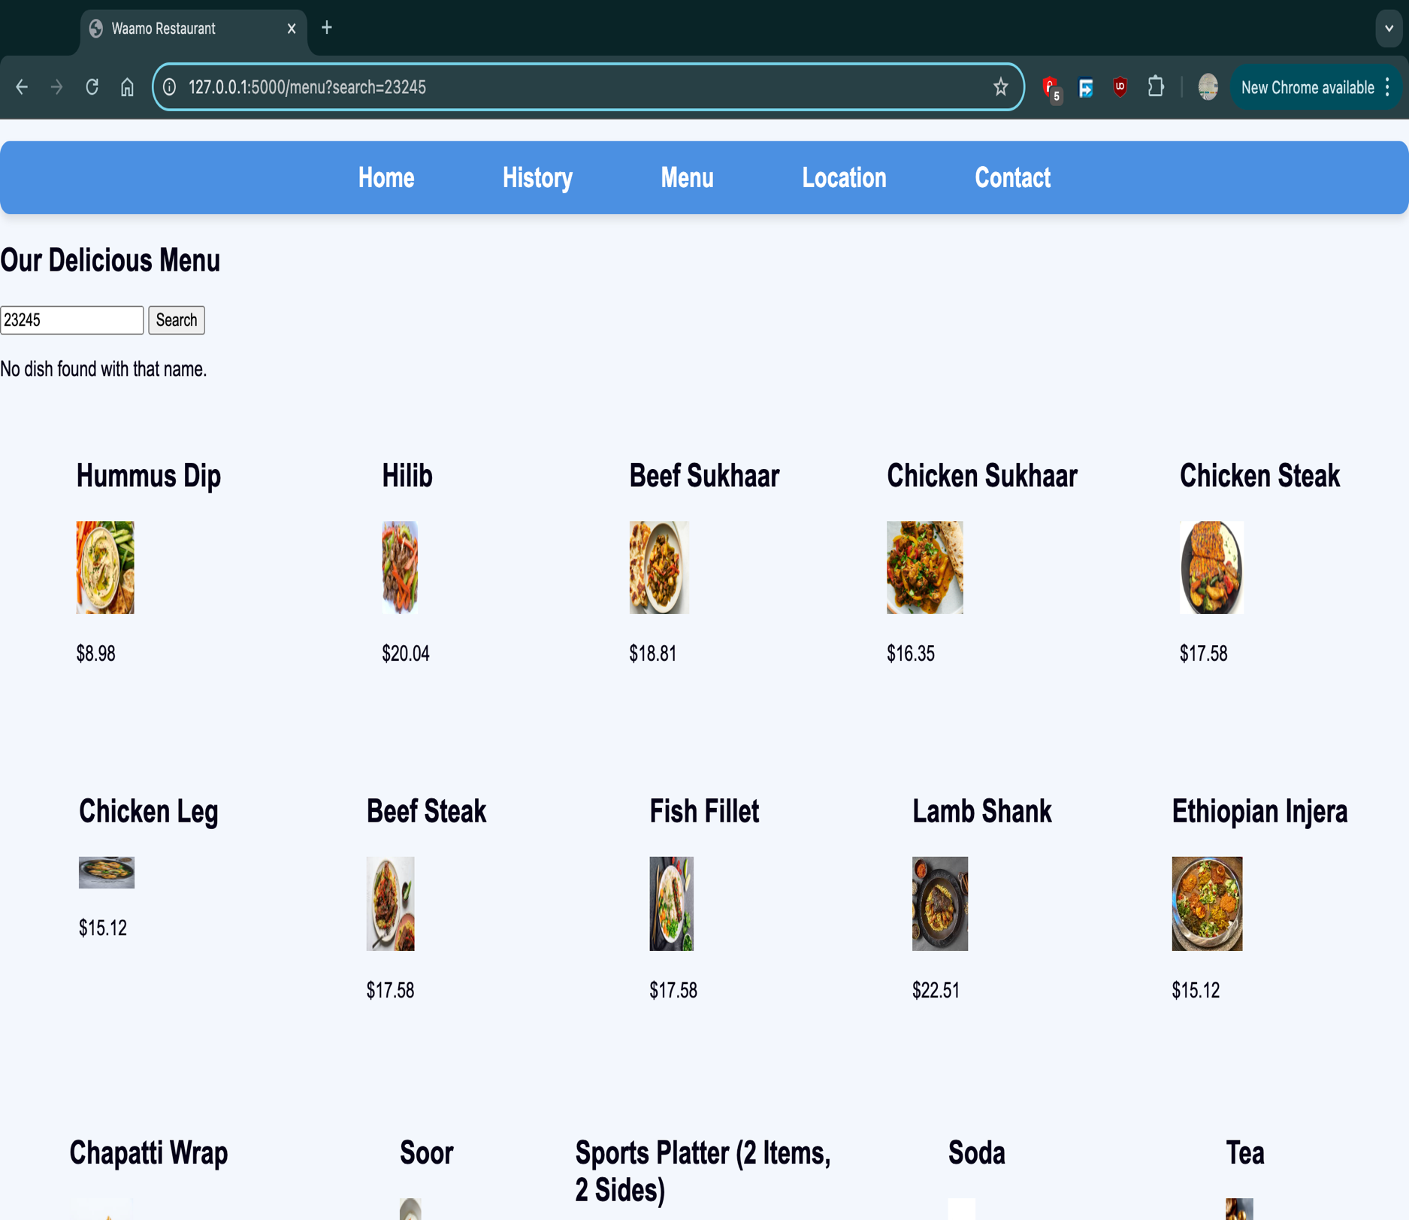

Explanation Continued: Menu Page Search feature – In the first visit to the menu page, the search feature will include a message stating ‘No dishes searched yet.” And if the searched button is clicked with entering any keyword or dish name, the page just refreshes while displaying that message. If unknown keyword or dish name that is not in the database and menu items is searched, a message will pop up stating ‘No dish found with that name.” These are some of the basic functionalities of the search feature in the menu page.

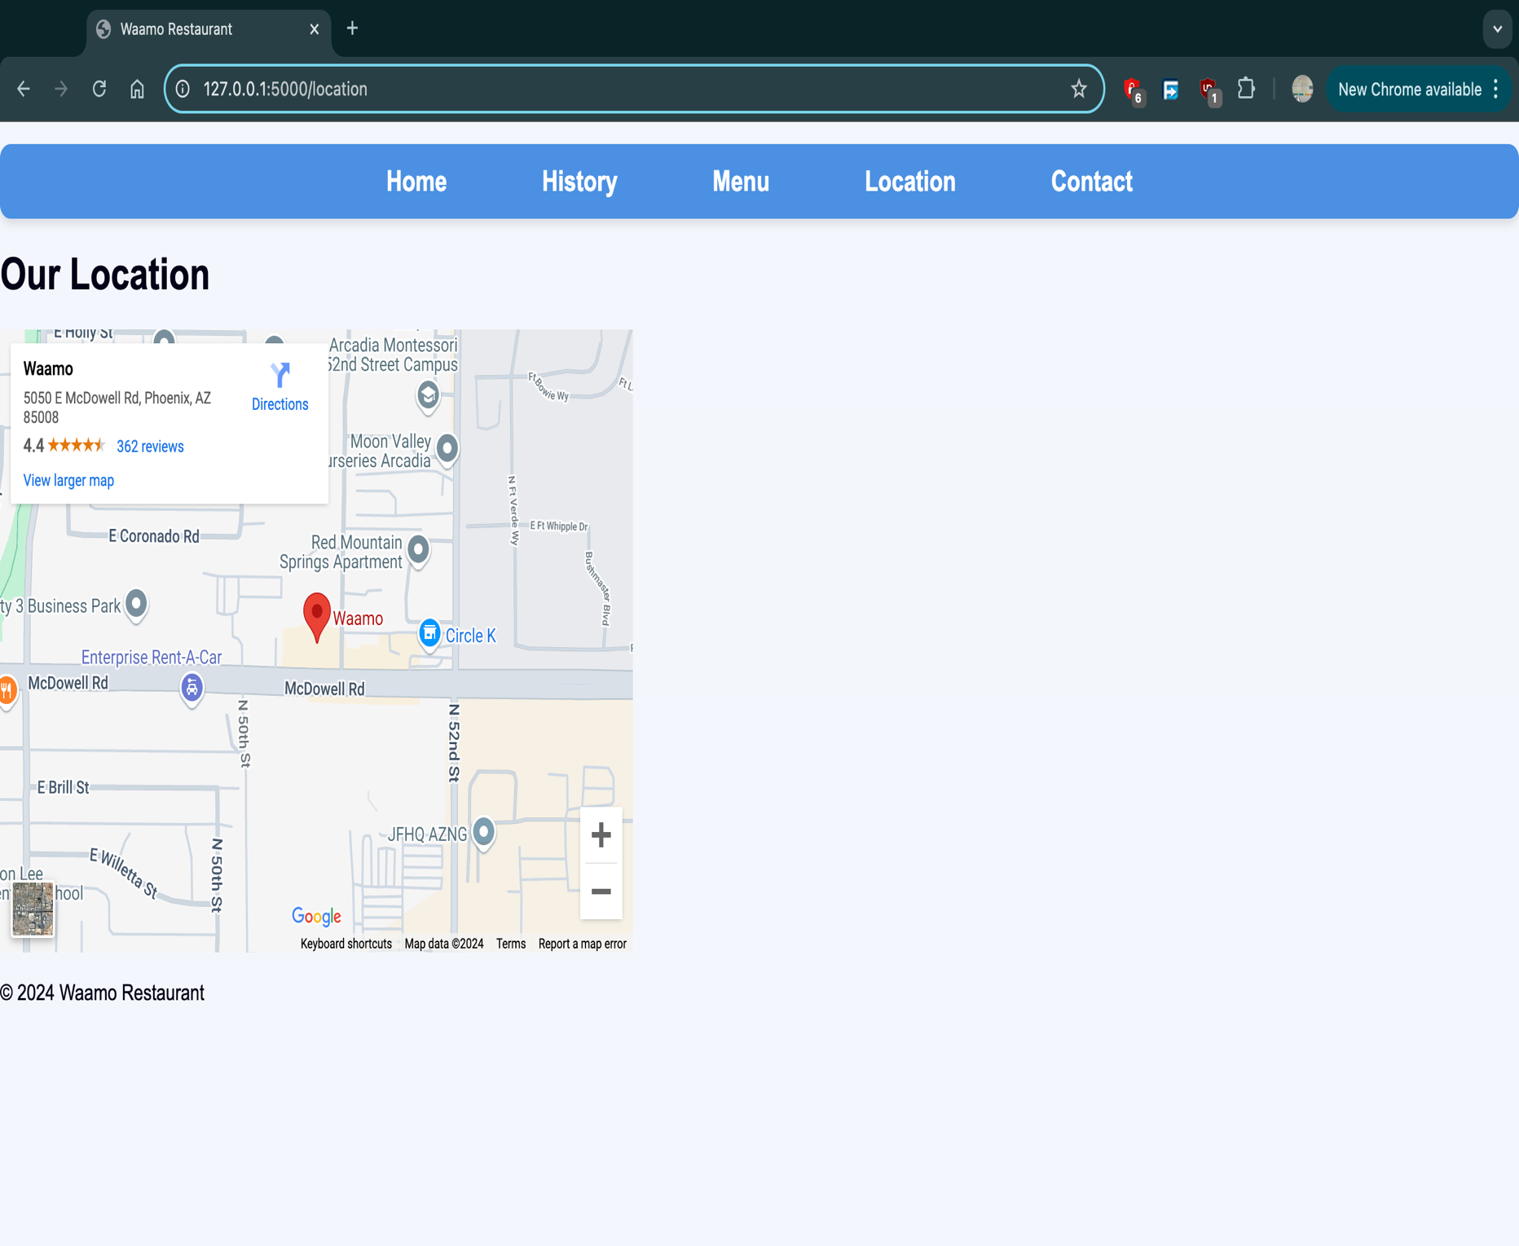

Explanation: Location Page - This page provides the exact location of the restaurant, and it is displayed with a map pin. It helps visitors find the restaurant easily, ensuring accessibility for potential customers.

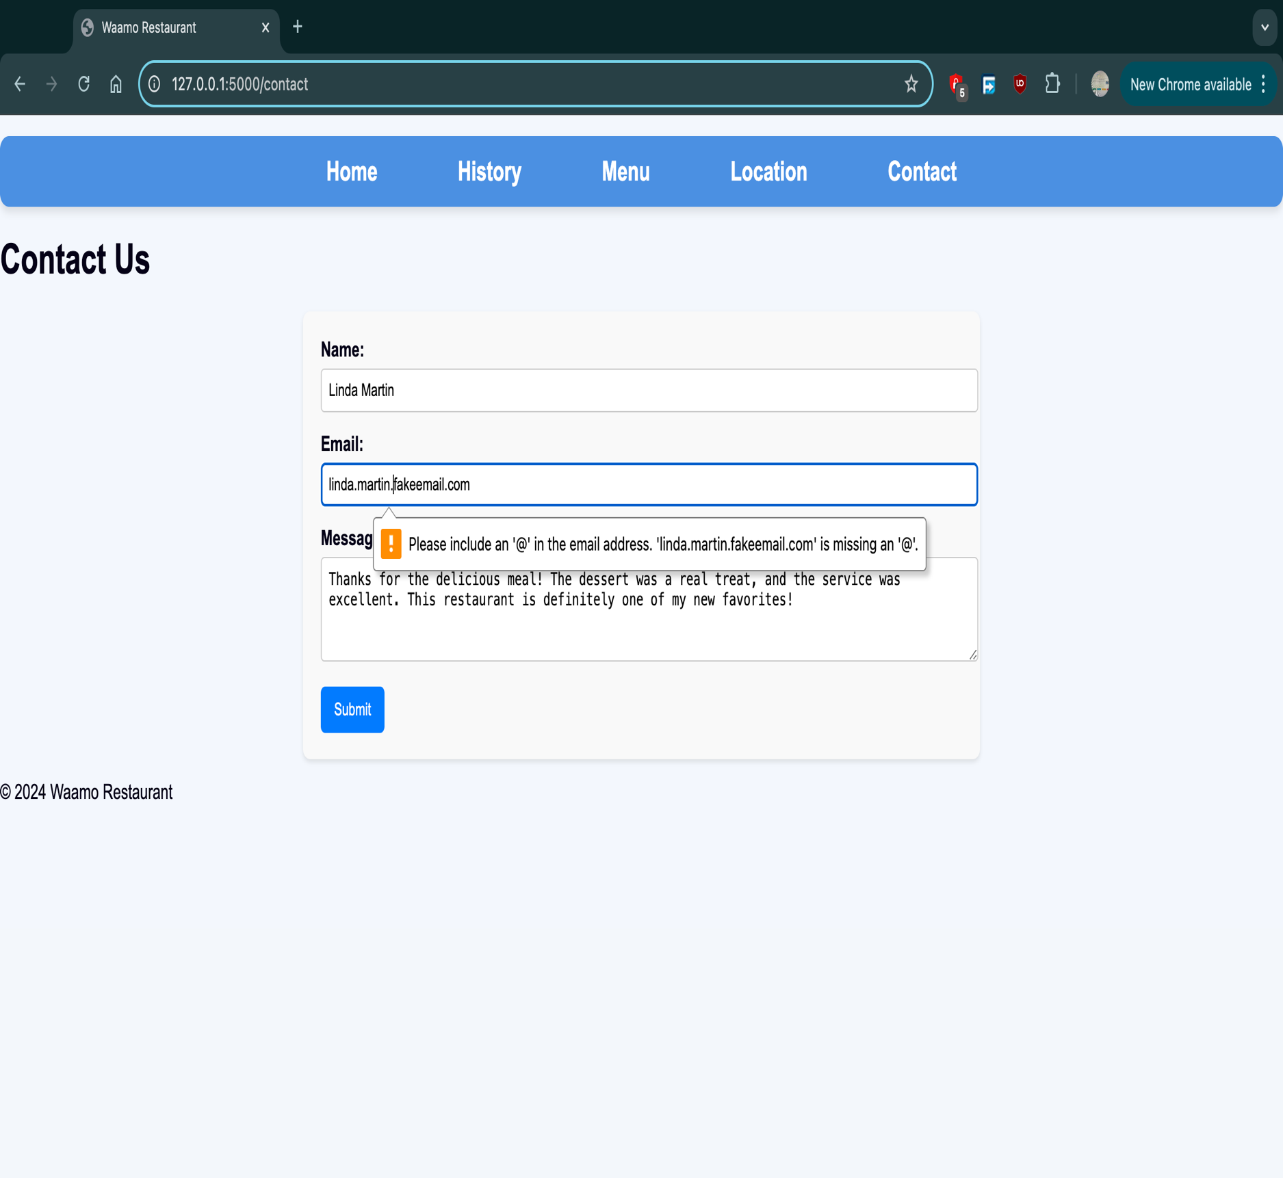

Explanation: Contact Page - This page allows users to reach out to the restaurant. It includes a contact form where users can leave their name, email, and a message (e.g., feedback or inquiries). The information submitted is stored in the database for further action by the restaurant staff. The ‘@’ sign is required in the email section for the message to be submitted in the database.

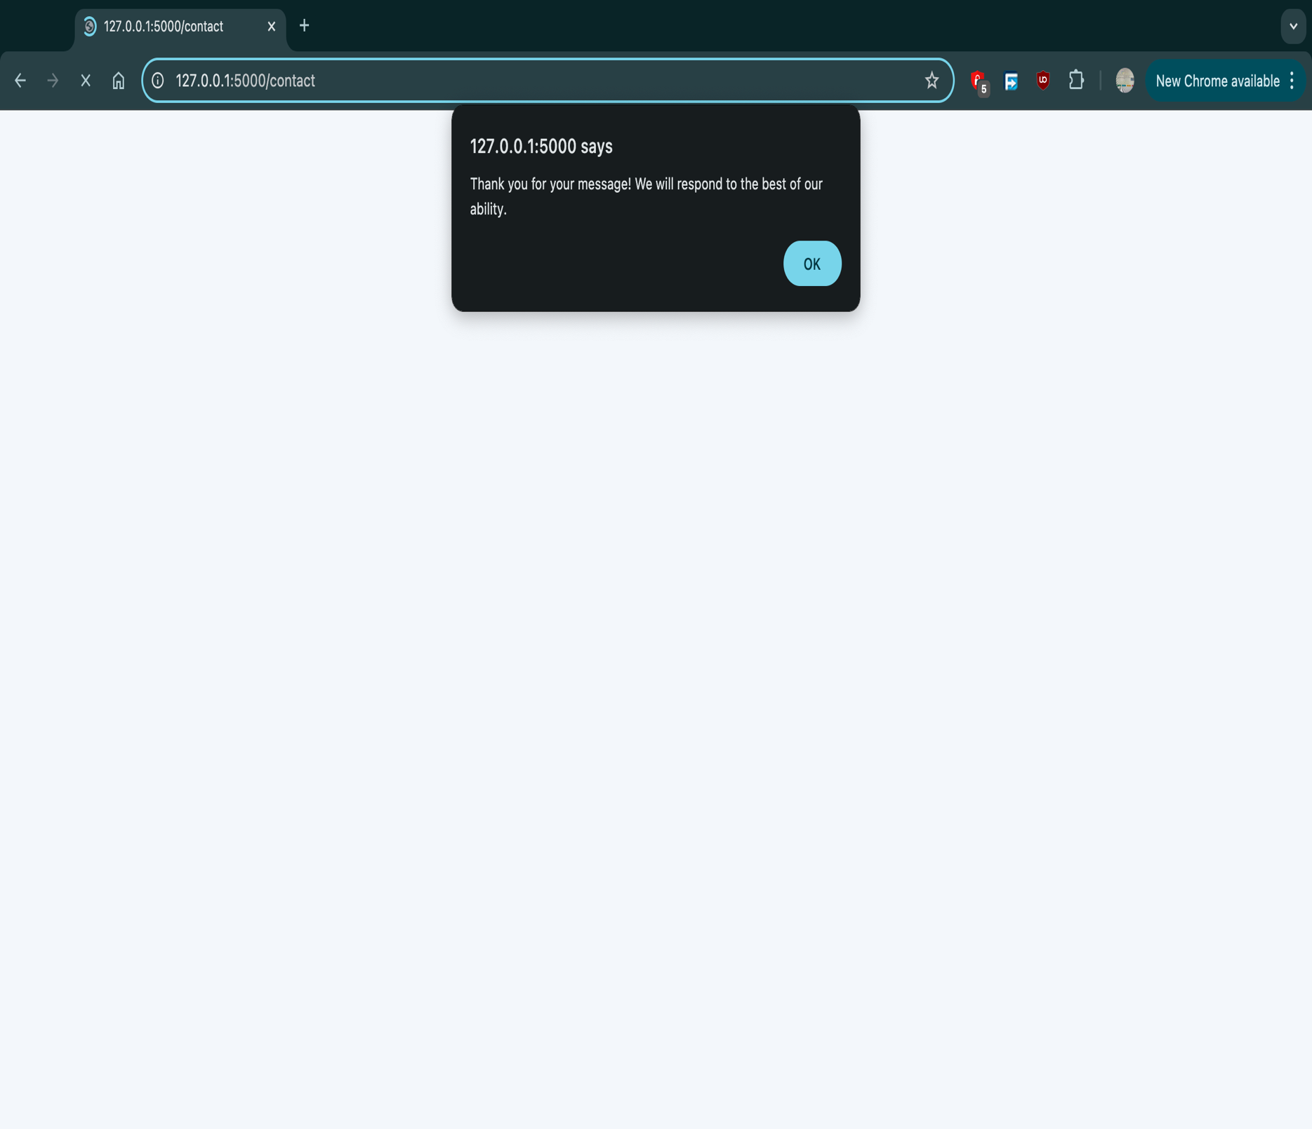

Explanation Continued: Contact Page – After a message is submitted successfully, a notification stating “Thank you for your message! We will respond to the best of our ability” Appears. The alert() command in JavaScript is used to get this effect. This pertains that the message is successfully in listed in the contacts table of the Waamo database.

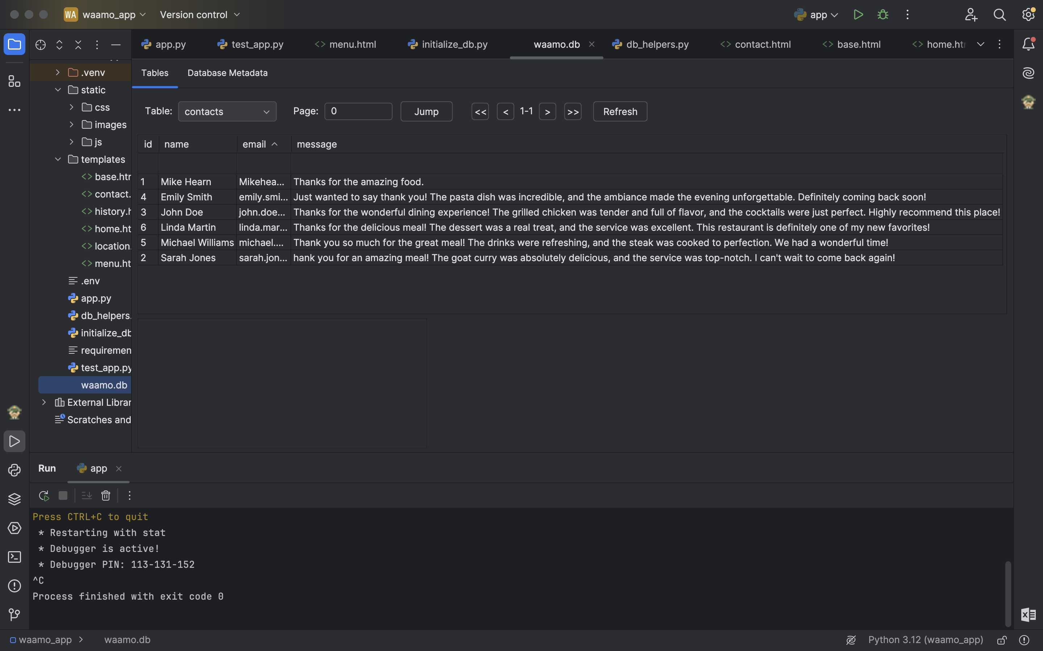

Explanation: Contacts Table - This table is used to store and manage communication between the restaurant and its patrons. Messages are logged here for review, allowing the restaurant to respond to feedback, inquiries, or requests. An auto increment primary key is set for every successfully logged message.

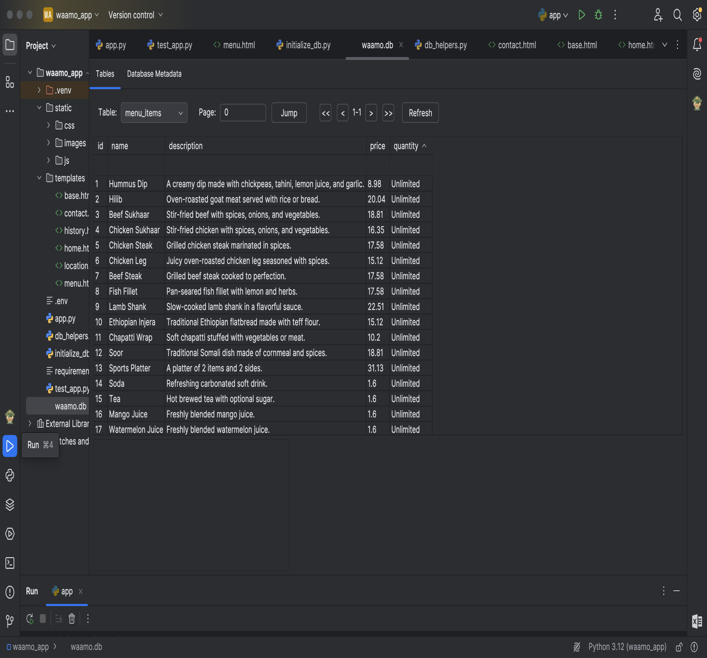

Explanation: Menu_items Table - This table is referenced when displaying the menu or searching for specific dishes. It helps keep the menu organized and easily manageable. The table is manually created with insertions for the menu items, descriptions, price and quantity. An auto increment primary key is also used for entity integrity. The quantity default value is ‘Unlimited.’

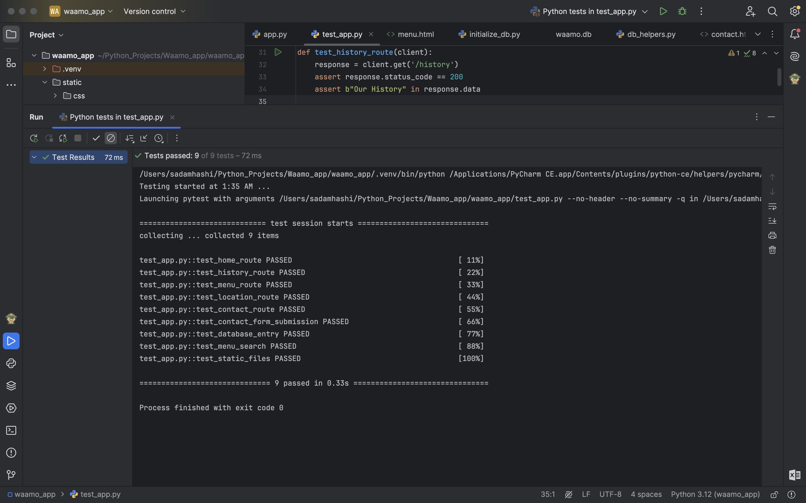

Explanation: Automated Testing Results - The automated testing confirmed the functionality of all core features in the application, with all 9 tests passing successfully. These tests verified the correct loading and behavior of key pages, including the home, menu, location, contact, and history pages, ensuring proper rendering and data handling. Database operations, such as saving contact form submissions and retrieving menu items, were validated alongside the search functionality, which filters menu items by keyword. Static files (CSS, images, JS) were also tested to ensure proper styling and functionality. Overall, the tests demonstrate that the application is robust, user-friendly, and ready for deployment.